1. Process Synchronization and Child Process Monitoring Using waitpid()
Code:

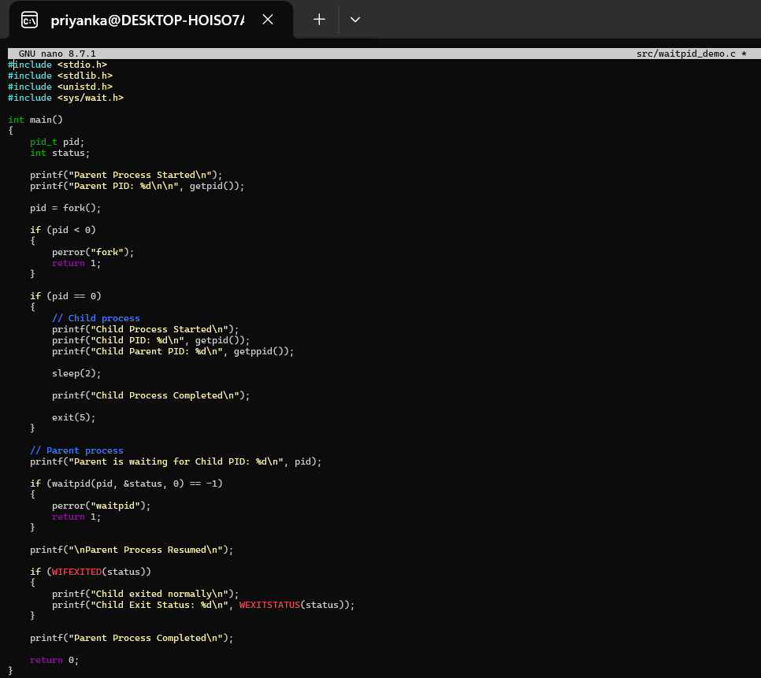Output: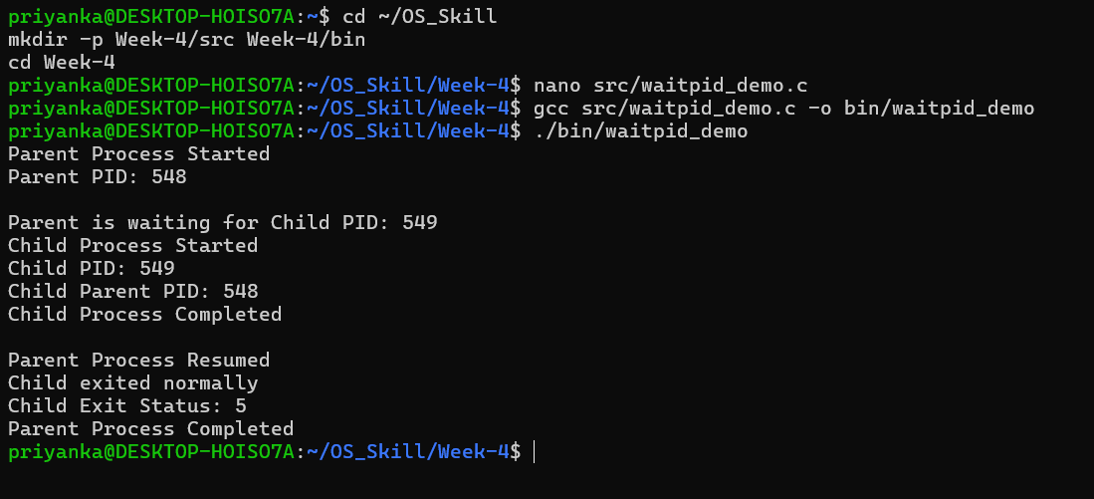
2. To Retrieve PATH Variable, Parse Search Directories, Locate Executables, Verify Permissions, Handle Missing Commands, Test Command Resolution
Code:
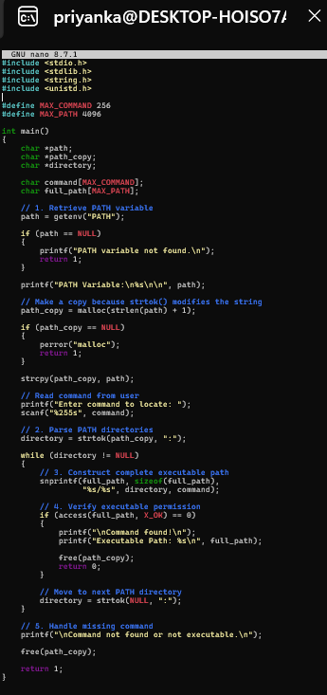

Output:
